# Diagrammatic Representation of Kanban Educational System Architecture

**Diagrammatic Representation of Kanban Educational System Architecture 1**

**Introduction 2**

**Use Case Diagrams 2**

Overview 2

Use Cases List 2

Use Case 1: Administrator grants permission for students to access Moodle through the API 2

Use Case 2: User moves Kanban Card 3

**Entity-Relationship Diagram (ERD) 5**

Purpose and Scope 5

ERD Diagram 5

**Data Flow Diagram (DFD) 6**

Overview 6

DFD Diagram 6

**Conclusion 7**

# 

# **Introduction**

This document provides a comprehensive overview of the system architecture for the educational tool that incorporates a Kanban board. It details how various stakeholders interact with the system, the database organization, and the data processing activities within the tool.

# Use Case Diagrams

## **Overview**

The use case diagrams depict the interaction of different user types (administrators, teachers, and students) with the Kanban board, outlining roles and responsibilities.

## **Use Cases List**

1. An administrator grants permission for students to access Moodle through the API

2. A student moves Kanban Board

3. An administrator manages user permissions for Kanban boards

4. An administrator generates reports from Kanban board activity

5. An administrator handles exceptions and errors in Kanban functionality  
6. A student comments on a Kanban card

7. A student archives completed tasks

## **Use Case 1: Administrator grants permission for students to access Moodle through the API**

| Use Case ID: | UC001 | | |
| --- | --- | --- | --- |
| Use Case Name: | Granting Permissions for API access | | |
| Created By: | Liubov | Last Updated By: | Liubov |
| Date Created: |  | Date Last Updated: |  |

| Actors: | Administrator | |
| --- | --- | --- |
| Description: | Administrator configures and manages board settings, including permissions, board categories, and default views. His main role is to grant permission for students to access Moodle assignments and courses through API. | |
| Trigger: | Administrator grants permission for students to access. | |
| Preconditions: | Administrator must be logged in with admin privileges. | |
| Postconditions: | Board settings are updated according to the specifications. | |
| Normal Flow: | 1. Administrator logs into the system. 2. Administrator navigates to the settings page from the dashboard. 3. Administrator modifies the board settings such as categories, user permissions, and default layouts. 4. Administrator reviews the changes and saves them. 5. System confirms the changes and logs the activity. | |
| Alternative Flows: | None | |
| Exceptions: | System fails to save changes due to a server error. | |
| Includes: | User Authentication | |
| Priority: | High | |
| Frequency of Use: | Weekly | |
| Business Rules: | Only administrators can alter board settings. | |
| Special Requirement: | Changes must be logged for audit purposes. | |
| Assumptions: | Administrators have appropriate training to manage board settings. | |
| Notes and Issues: | Ensure timely server responses to avoid delays. | |

## **Use Case 2: User moves Kanban Card**

| Use Case ID: | UC002 | | |
| --- | --- | --- | --- |
| Use Case Name: | Move Kanban Card | | |
| Created By: | Liubov | Last Updated By: | Liubov |
| Date Created: |  | Date Last Updated: |  |

| Actors: | User (Student) | |
| --- | --- | --- |
| Description: | User moves a Kanban card from one column to another to update the status of the task. | |
| Trigger: | The User decides to update the status of a task represented by a Kanban card. | |
| Preconditions: | 1. User must be authenticated and authorized to access the specific course and Kanban board. 2. The Moodle API must be available and functional. 3. The task (Kanban card) exists on the Kanban board. 4. The columns (statuses) to move between must be defined and exist on the board. | |
| Postconditions: | 1. The Kanban card's new status is updated in the Moodle course database. 2. The user interface reflects the Kanban card’s new position. 3. Activity logs record the action of moving the card. | |
| Normal Flow: | 1. The user accesses the Moodle Kanban Board. 2. The user navigates to the specific course and respective Kanban board section. 3. The user locates the Kanban card representing the task whose status needs updating. 4. The user drags the Kanban card from its current column to the target column (representing the new status). 5. The system detects the drop action and triggers an update via the Moodle API. 6. The API updates the task’s status in the Moodle course database. 7. The UI updates to show the card in its new destination column. 8. An activity log entry is created for this action. | |
| Alternative Flows: | If the column drag-and-drop action is aborted, the card remains in the original column and no changes are made in the database. | |
| Exceptions: | * If the Moodle API is unavailable, the operation is aborted, and an error notification is displayed to the user. | |
| Includes: | * Authenticate User * Update Task Status in Database | |
| Priority: | High | |
| Frequency of Use: | Several times per day per user, depending on the number of tasks and workflow complexity. | |
| Business Rules: |  | |
| Special Requirement: | * Smooth, intuitive drag-and-drop interface. * Immediate visual feedback when moving cards. | |
| Assumptions: | The user understands the meaning of each column's status. | |
| Notes and Issues: |  | |

ERD Diagram - for Eugene's work on the databases. They will show how different entities (e.g., users, tasks, courses) are connected to each other.

# Entity-Relationship Diagram (ERD)

## **Purpose and Scope**

This section explains the aim and extent of the database diagram curated by Eugene, emphasizing its role in managing and representing relationships.

## ERD Diagram

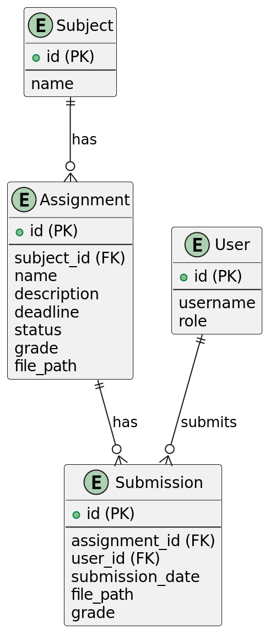

# Data Flow Diagram (DFD)

## **Overview**

Provides a high-level introduction to the DFDs, presenting how data flows through the system when users interact with the Kanban board.

## **DFD Diagram**

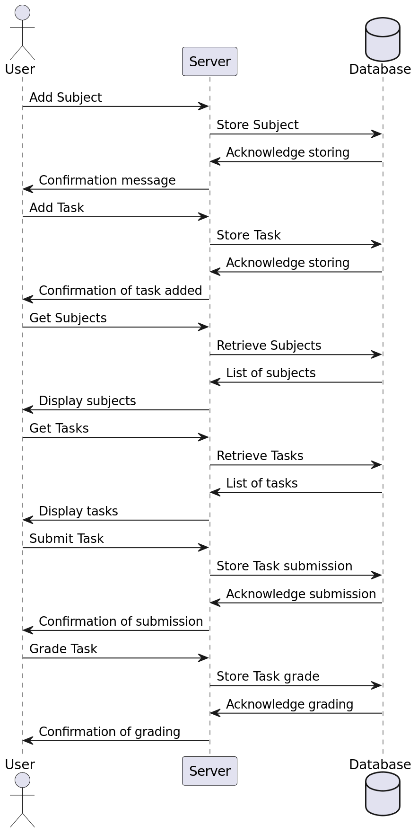

# Conclusion

This document has effectively outlined the interactions, data structures, and processes within our educational tool utilizing use case diagrams, ER diagrams, and data flow diagrams. These comprehensive visual representations provide a clear blueprint for understanding, maintaining, and further developing the system. Through this documentation, stakeholders are equipped to make informed decisions, optimize performance, and enhance the educational experience.